Students can access ExamView tests by downloading the appropriate Examview Student app for their device

For Chromebooks: https://tinyurl.com/examview-student

Android - Phone: https://play.google.com/store/apps/details?id=com.turningtechnologies.vpad.examview

iPhone (iOS): https://apps.apple.com/us/app/examview-student-phone/id1157548238?ls=1

PC (Windows): https://tinyurl.com/examview-student-pc

Apple (Mac 32-bit only): https://d2p83s3q5aa83e.cloudfront.net/wp-content/software/ExamView/ExamViewStudentMac-01.00.00-0249.pkg

Android - Tablet: https://play.google.com/store/apps/details?id=air.com.turningtechnologies.vpad.tablet.examview

iPad: https://apps.apple.com/us/app/examview-student-pad/id1157548826?ls=1

Above links here found here: https://www.turningtechnologies.com/downloads/examview/
Scroll down to the section titled Examview Premium - student apps

Examview Student can be accessed by students from the http://examview-student.com site.

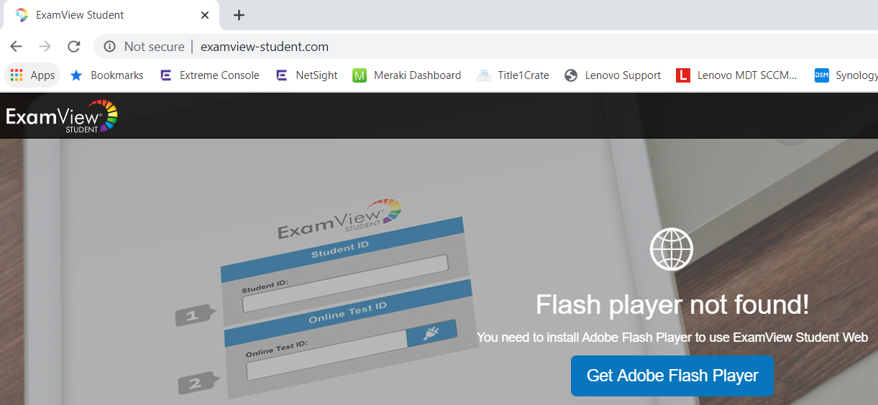

The above site requires flash player. It’s already installed in Chrome it just needs to be enabled.

To enable flash for the site click the circled i next to Not secure near the address.

The following appears, click Site settings
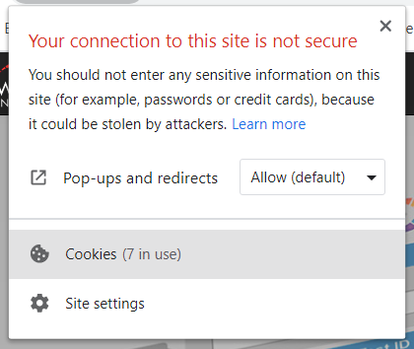
Make sure that Flash is set to Allow.
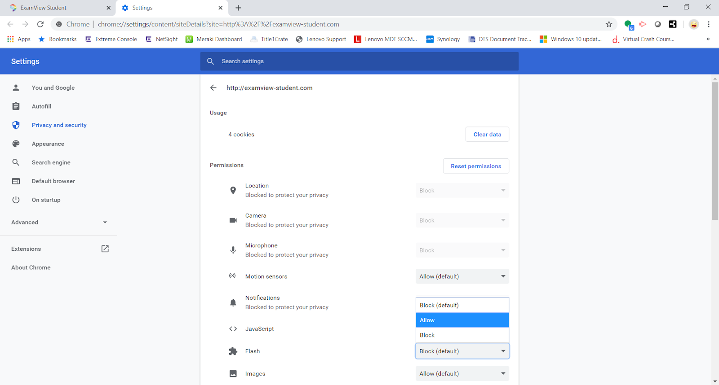

If you need to access the settings again for the examview-student site copy and paste the below into the address bar into chrome.
chrome://settings/content/siteDetails?site=http%3A%2F%2Fexamview-student.com

